  EMIRATES CENTER FOR WILDLIFE PROPAGATION  Province de Boulemane - B.P. 47  33250 Missour  ROYAUME DU MAROC  Tél. : +212 (0)5 35 58 57 52  Fax : +212 (0)5 35 58 52 06  E-mail : houbara@ecwp.net.ma | Field protocol | N° d’identification :  Standardized_Houbara_Counts_Compilation.docx
Houbara COUNT protocols  Morocco  Compilation 2001-2014 |  | Created:  17/10/2014
Last update:
22/07/2025

Number of pages:
6

- Contents

1. Contents 1
2. Objectives 2
3. General principles 2
4. Conditions of application common to all protocol variations 2
5. Preliminary work 2
6. Common operating protocol 3
7. Modifications of the protocol 4
8. Evolution of the number of observation points 5

- Objectives
- Assessing the density and distribution of a population of Houbara in a selected area according to the type of landscape;
- Monitoring the density evolution and distribution of the population by duplicating the same protocol during a given period.
- General principles
The method of observation points was defined from tests realized in ECWP center in January-February and July-August in 2001 as well as from bibliographic research about census technics. The final selected method was the variable radius point count.
Reference observation points are regularly distributed in the studied area. Individuals are counted by realizing a circular observation (360°) during a defined duration. Distances between individuals detected and observers are measured with accuracy. The density of the population is deduced from the detection probability of the individuals and calculated from the distances of observation.
In the case of Houbara bustards in Morocco, the detection of individuals is processed with binoculars from observation points. The distance between two observation points is generally 3 km. This distance usually allows minimizing disturbances between two successive points (the visual range is generally lower than 1.5 km).
- Conditions of application common to all protocol variations
- A team is constituted of 2 observers;
- A distance of at least 6km is required between 2 teams in order not to disturb the operations;
- In the best cases, an area has to be surveyed during a period that does not exceed 8 days in order to avoid bias linked to individuals movements;
- A minimum of 60 observations is required for an accurate assess of the density;
- All the observation points from a grid should be realized;
- When several visits are needed, the order in which the observation points are realized should be modified between each visit. The teams visiting the observation points should be alternated. This should allow minimizing bias linked to the day time and observers.
- To keep a homogenous observation quality, counts should not be proceeded when detection conditions are not optimal (heat haze, cloudiness, wind).
- Observation points can be visited from sunrise until 3h after sunrise and from 2h before sunset until sunset.
- Preliminary work
Defining a grid of theoretical points from GIS;
Validating the theoretical points in the field. A point is eliminated when:
  - It is not accessible;
  - It is located near houses;
  - It does not provide a 360° visibility.
In the last 2 cases, the point can be moved on higher area within the limit of 500m radius.
The validation is realized during the very first visit of a counting area. This operation is realized only once, and then the counting grid is considered as definitive. All validated points are used as reference observation points, and will be loaded in the GPS for future surveys.
- Common operating protocol
- The observers go to the observation point using their GPS and field tracks to limit the environment degradation. The arrival on the observation point is made at a low speed in order not to disturb the observation area.
- The real observation point can occasionally be moved within a defined radius distance (new field, tent …). In all cases, waypoint of the real observation point is recorded at each visit.
- One of the two observers records the waypoint and notes information in the Counting field data sheet. In the meantime, the second observer does a circular observation with naked eye to detect birds that could be close to the car.
The information characterizing the observation point are noted on the field data sheets:
  - Arrival time;
  - Name of the effective count point (2 letters, 2 numbers, based on the reference point name. For example: BA01);
  - Waypoint coordinates;
  - Date;
  - Observers’ name;
  - Landscape, 3 main vegetal species, vegetation cover;
  - Anthropogenic impacts;
  - Wildlife;
  - Others.
- Each observer prospects the whole landscape around the observation point by a circular observation (360°) with binoculars. The observation duration is defined by the current protocol.
- When a group of Houbara is detected, the observation is confirmed by the other observer with binoculars or telescope. Detection delay, group size, sex and age of the individuals are recorded. The location of the group is noted by taking landmarks.
- At the end of the circular observation, the observers go to the location of each. If the group moved, the observers go to the place the group was detected from the observation point. Between each group, the team goes back to the observation point to take landmarks of the following group. Several information is recorded for each group:
  - Creation of waypoint of the location of the group
  - Name of the waypoint (Name of the observation point + incremented letter: BA01A, BA01B, BA01C);
  - Coordinates of the waypoint;
  - Distance between the group and the real observation point read on the GPS;
  - Landscape, 3 main vegetal species, vegetation cover;
  - Number of individuals detected from the observation point as well as general behaviour, even if they are different while getting close to the group.
- Once all the groups located, the observers leave the area and go to the following point.
- If wildlife or anthropogenic impact is observed, the location is given as accurately as possible by a projected waypoint on the GPS (until 2018) or by estimating the distance and the bearing (since 2019). The name of the point when relevant, its coordinates and other information are noted on the corresponding sheet. The waypoint code is noted on the counting sheet.
- If no group of Houbara was detected during the circular observation, the observers go directly to the following point.
When Houbara are observed out of observation point, the information about location, group size, sex and age are recorded on the classical Houbara observation sheet.
- Modifications of the protocol
Tableau 1 : Evolution of different points of the Houbara count protocol since 2001
Part of the protocol concerned | Year | Modification
Counting period | 2001-2002 | Once a year, except for Al Baten and Tamlet counted once by season
Counting period | 2003-2006 | Al Baten once by season, Tamlelt before and after hunt
Counting period | 2009 | From September to November
Counting period | Since 2010 | From September to December
Limit radius distance for moving the real observation point | 2001-2008 | 500m from the reference observation point
Limit radius distance for moving the real observation point | Since 2009 | 300m from the reference observation point
Meteorological data | 2001-2008 | Temperature, cloudiness, wind force
Meteorological data | Since 2009 | None
Observation duration and observation process | 2001-2006 | 30 minutes  One of the observers begins a circular observation with naked eye to detect Houbara fleeing from the observation point area. Then he processes to the circular observation with binoculars while the other one takes notes of the characteristics of the observation point. The observers begin the observation few minutes apart.
Observation duration and observation process | Since 2007 | 20 minutes  One of the observers begins a circular observation with naked eye to detect Houbara fleeing from the observation point area.  Then two observers begin the observation at the same time.
Observation tool | 2001-2002 | Around 10 minutes with binoculars and 20 minutes with telescope
Observation tool | Since 2004 | Binoculars. Telescope used for confirmation
Observation angle | 2001-2003 | Each observer scans 180° of range, so that each side of the car is well prospected
Observation angle | Since 2004 | 360°  Oservers turn in the same direction, watching in opposite direction
Place of the observers | Since 2013 | 1 on the ground, 1 from the footboard of the car
VHF radio-tracking | 2001-2003 | VHF scanning of the groups with the TR5 receiver to check if there is an equipped individual in the group. Noting if check done and frequencies detected.
VHF radio-tracking | 2004-2006 | No VHF scanning
VHF radio-tracking | 2007 | VHF scanning by a third observer. Association of the observation point method with the capture-marking-recapture method
VHF radio-tracking | 2009 | VHF scanning
VHF radio-tracking | Since 2010 | No radio-tracking
Anthropogenic impact | 2001-2006 | In a radius of 1 km around the observation point and locations of Houbara groups
Anthropogenic impact | Since 2007 | In a radius of 1.5km around the observation point
Wildlife | 2001-2002 | All species, except very common ones
Wildlife | 2003 | Raptors, ungulates, lagomorphs, reptiles, felids and canids
Wildlife | 2004 | According to the knowledge of observers plus rare or remarkable species
Wildlife | Since 2009 | Predators and ungulates in a radius of 1.5km around the observation point

Evolution of the number of observation points
Before 2020, the grid of reference points was visited as many times as necessary to reach a minimum of 60 groups of Houbara (minimum required to get strong density analysis). Since 2020, a second grid has been interposed to the original one in most of the areas, to increase the effort while reducing the risk of autocorrelation. The evolution of the number of reference points by area surveyed during several years are presented in Table 1. The repartition of all observation points since 2001 in.
Table 1 : Number of validated observation points by year and area. Areas not monitored anymore are shaded in grey (Update 2025). In red, points on a 6x6km square grid
 | Eastern Morocco |  |  |  |  |  | Tata
 | Al Baten | Enjil | North Maatarka | South Maatarka | Moulouya | Tamlelt | Akka | Faija
2001 | 60 | 29
2002 | 59 |  | 66 |  |  | 173
2003 | 58
2004 | 56 |  |  |  |  | 173
2005 | 56 |  |  |  |  | 173
2006 | 56 |  |  |  |  | 173
2007 | 39 | 26 |  | 45 |  | 76
2008 | 39 | 26 |  |  |  | 76
2009 | 39 | 26 |  |  |  | 76
2010 | 39 | 26 |  |  |  | 76 |  | 46
2011 | 39 | 26 | 64 |  | 77 | 76 | 44 | 47
2012 | 39 | 26 | 64 | 45 | 77 | 76 | 44 | 47
2013 | 39 | 26 | 233 |  | 77 | 76 | 44 | 47
2014 | 39 | 26 | 232 | 45 | 77 | 76 |  | 47
2015 | 39 |  | 233 | 117 | 96 | 76 | 44 | 47
2016 | 39 |  | 232 | 117 | 96 | 76 | 93 | 47
2017 | 39 |  | 232 | 117 | 96 | 76 | 93 | 47
2018 | 39 |  | 232 | 117 | 96 | 76 | 49 | 47
2019 | 39 |  | 232 | 117 | 96 | 76 | 49 | 47
2020 | 75 |  | 232 | 228 | 192 | 152 |  | 88
2021 | 75 |  | 232 | 228 | 192 | 152 |  | 88
2022 | 75 |  | 232 | 228 | 192 | 207 |  | 88
2023 | 75 |  |  | 136 | 130 | 207 |  | 88
2024 | 75 |  | 232 | 228 | 192 | 207 |  | 88

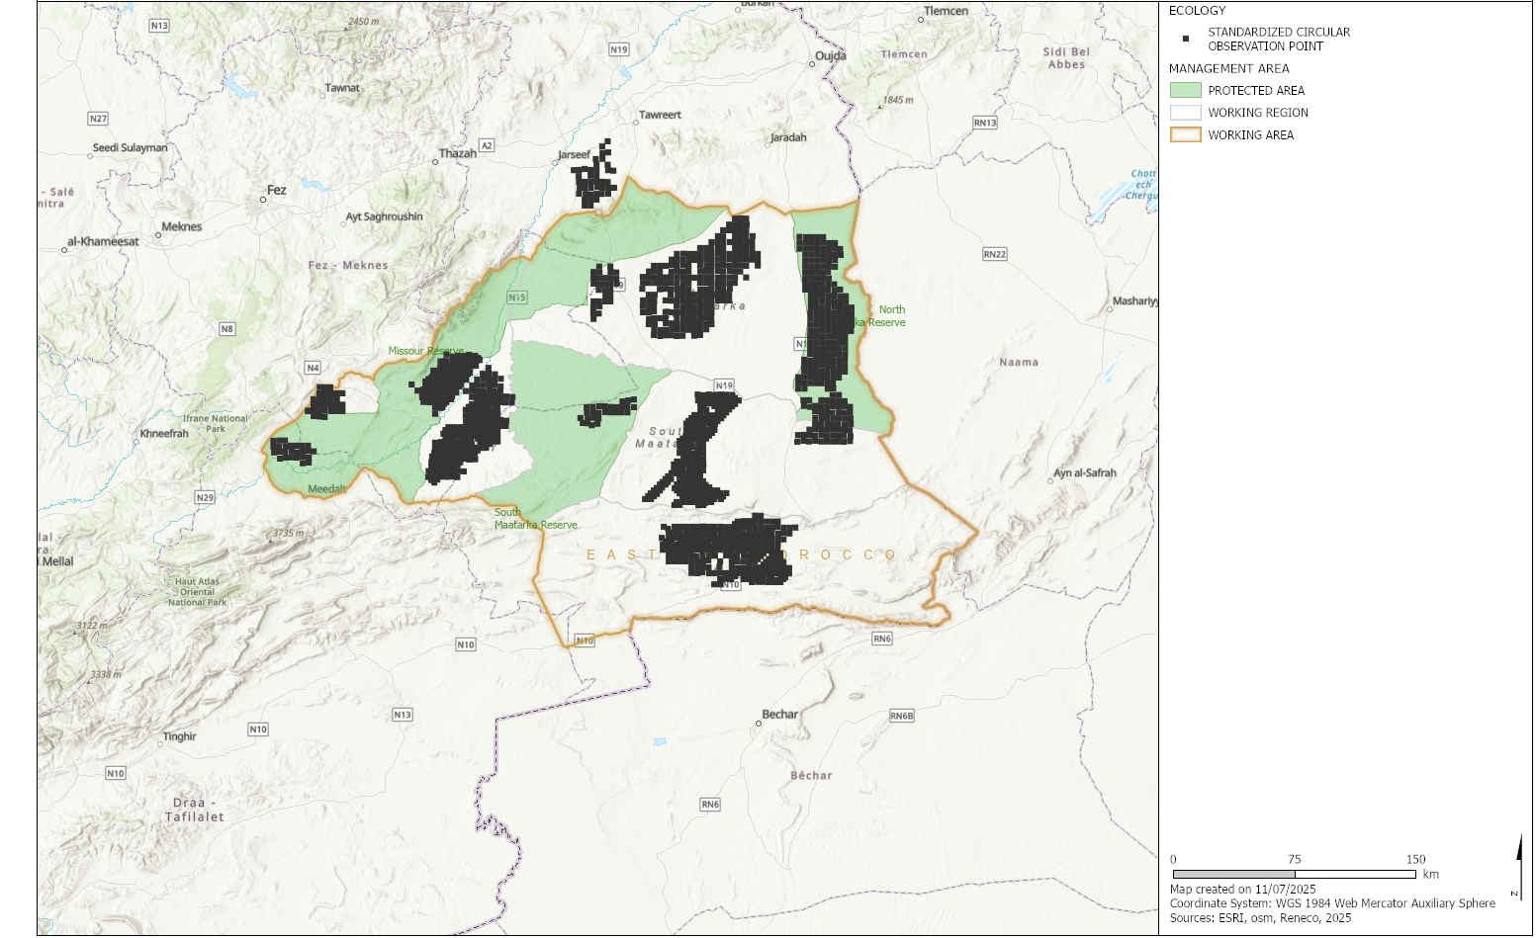
Figure 1. Location of standardized circular observation points in Eastern Morocco between 2001 and 2024

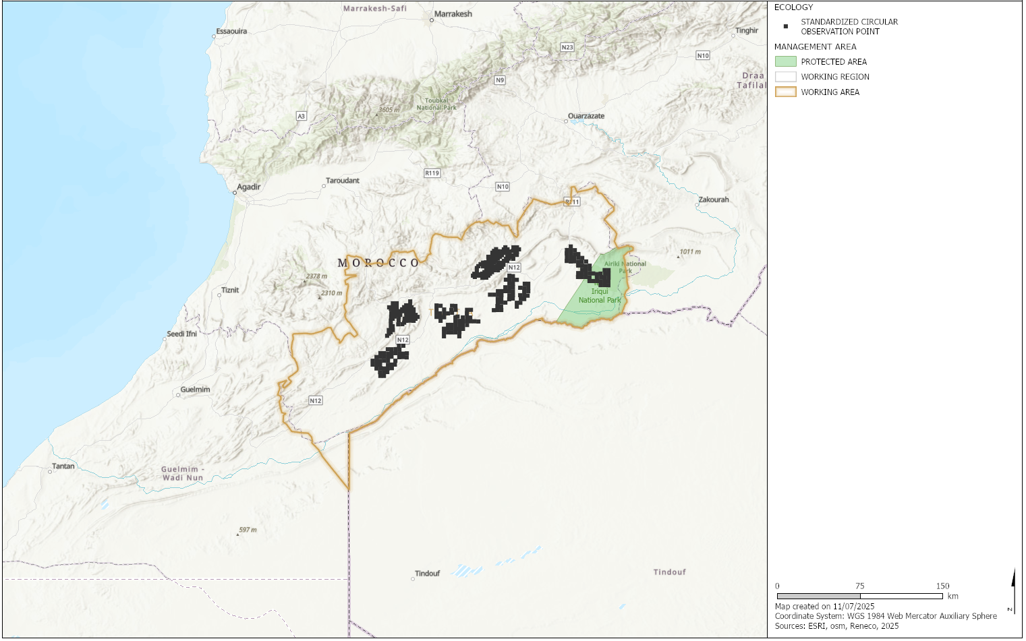
Figure 2. Location of standardized circular observation points in Tata, Morocco between 2001 and 2024

